ShopNest Store Capstone
Dashboard Report — With Real Insights & Screenshots

Prepared by: Nannapaneni Sravani
Date: 21-Dec-2025

Executive Summary
The Power BI dashboard consolidates retail performance for ShopNest across orders, sales, delivery timeliness, payments, product ratings, geography, seasonality, and revenue trends. Key KPIs with **MonthName = All**, **State = All**, **Category = All**:
- Total Revenue: **16.01M**
- Total Orders: **99.441K**
- Total Sales (units): **10.51K**
- Average Rating: **4.07** / 5

What Was Built in Power BI
• One-page summary with side navigation (Summary, Category, Ratings, Trends).
• Slicers: MonthName, State, Category Name.
• DAX measures for revenue, orders, units, ratings, delayed/on-time flags, YoY and YTD.
• Eight visuals mapped to capstone tasks.

1)Top Categories by Total Price
- Task Number: 1
  - Identify and visually represent the top 10 product categories by total sales.
- Visual: Clustered Column chart — Top 10 categories by Total Sales.
- Explanation: For this task, I created a Clustered Column Chart in Power BI to show the Top 10 product categories by Total Sales.
- The chart ranks categories based on their total sales value.
- From the visual, small_appliances is the highest-selling category, followed by computers, construction_material, and health_beauty.
- Other categories like stationery, housewares, luggage_accessories, perfumery, and pet_shop have comparatively lower sales.
- This chart helps identify which categories contribute most to revenue, so the business can focus on top-performing categories for promotions and inventory planning.
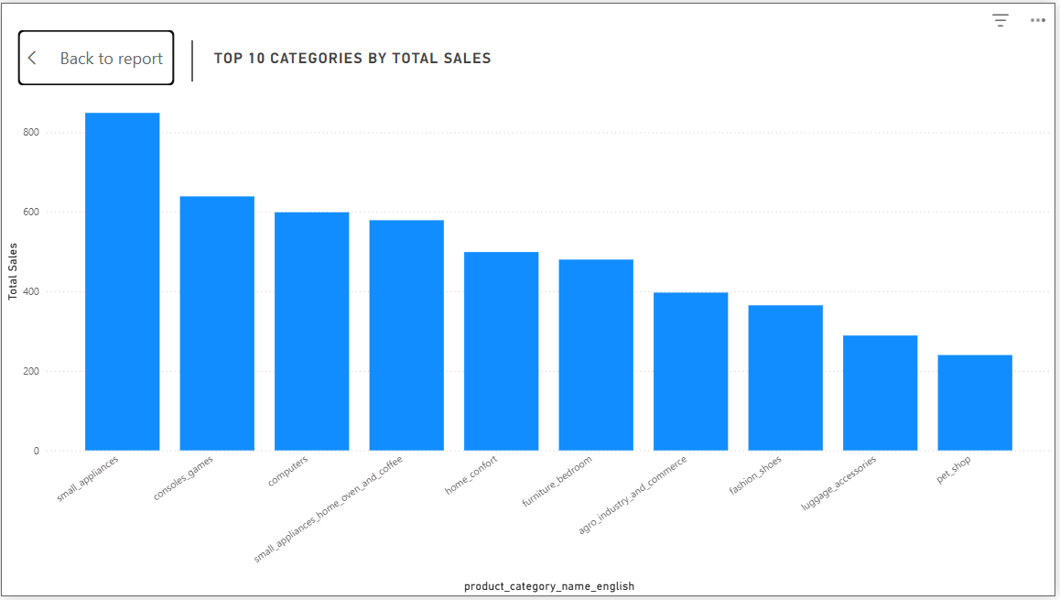
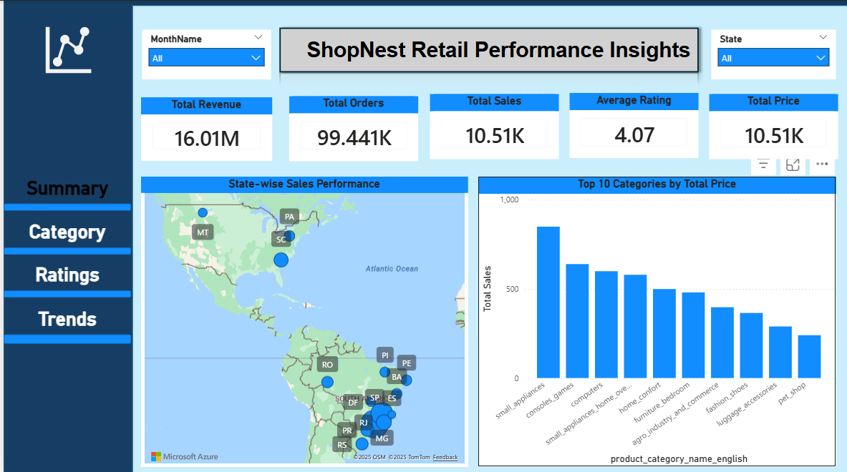
Summary page — Top 10 Categories by Total Sales

2) Delayed Orders Analysis (by Category)
- Task Number 2:
  - Determine the number of delayed orders in each category. An order is considered delayed if the actual delivery date is later than the estimated delivery date.
- Visual: Stacked chart of Delayed Orders per category.
- Explanation: For this task, I created a stacked chart in Power BI to show the number of delayed orders for each product category.
- An order is considered delayed if the actual delivery date is later than the estimated delivery date.
- From the visual, the computers category has the highest number of delayed orders (around 7.8K), while other categories like construction_tools_garden, office, fashion_bags_accessories, and furniture_living_room have very few delays.
- This analysis helps identify which categories face delivery challenges so the business can improve logistics and supplier performance for those categories.

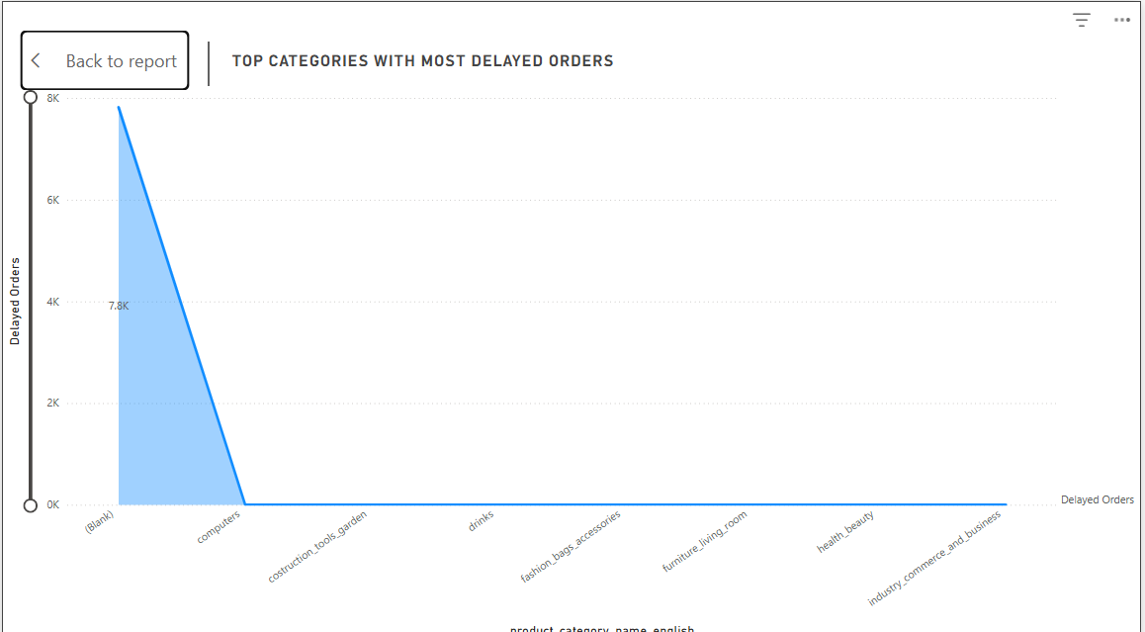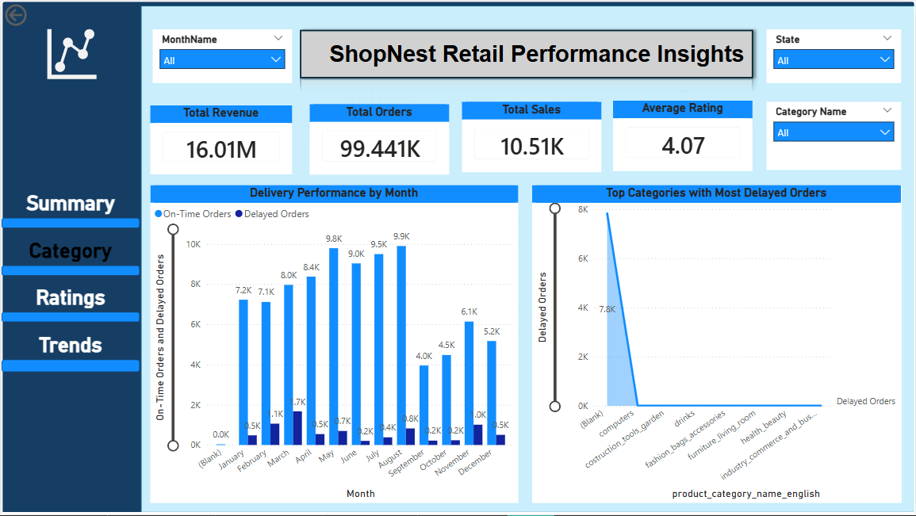
Category page — Top categories with most delayed orders

3) Monthly Comparison of Delayed vs On-Time Orders
- Task 3:
  - Create a dynamic visual that compares the number of delayed orders to the number of orders received earlier for each month. Utilize the dillthrough cross-report feature to provide a detailed analysis of late and on-time deliveries
- Visual: Clustered Column chart (columns for On-Time and Delayed) with drill-through.
- Explanation: The chart uses two columns per month: one for On-Time Orders (blue) and one for Delayed Orders (dark blue).
- From the visual:
- On-Time Orders are consistently high, peaking in July (~9.9K) and June (~9.5K).
- Delayed Orders remain low across months, mostly below 1K, with slightly higher delays in March (~1.7K) and November (~1K).
- This comparison helps identify months where delivery performance dips, so the business can plan better for peak periods and reduce delays.
- I also enabled drill-through functionality, allowing users to click on a month and view detailed delivery data by category and state.
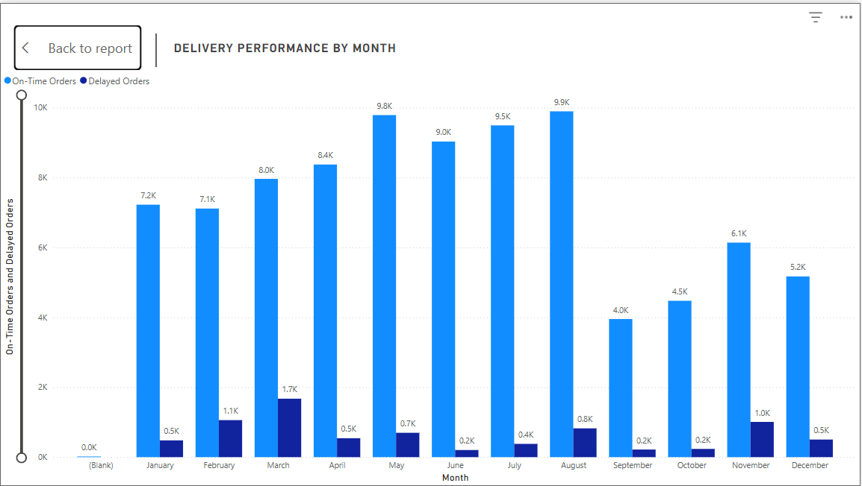
Delivery performance by month

4) Payment Method Analysis
- Task 4:
  - Analyze the most frequently used payment methods by customers using a visually appealing representation, such as a pie chart or other suitable visuals.
- Visual: Pie chart of order count by payment type.
- Explanation: For this task, I created a Pie Chart in Power BI to show the distribution of payment methods used by customers.
- The chart visually represents the share of each payment type based on the number of orders.
- From the visual:
- Credit Card is the most used payment method with 77K orders (73.32%).
- Boleto accounts for 20K orders (19.04%).
- Voucher contributes 6K orders (5.56%).
- Debit Card and Not Defined have very small shares.
- This analysis helps the business understand customer payment preferences and optimize payment options or promotions accordingly.
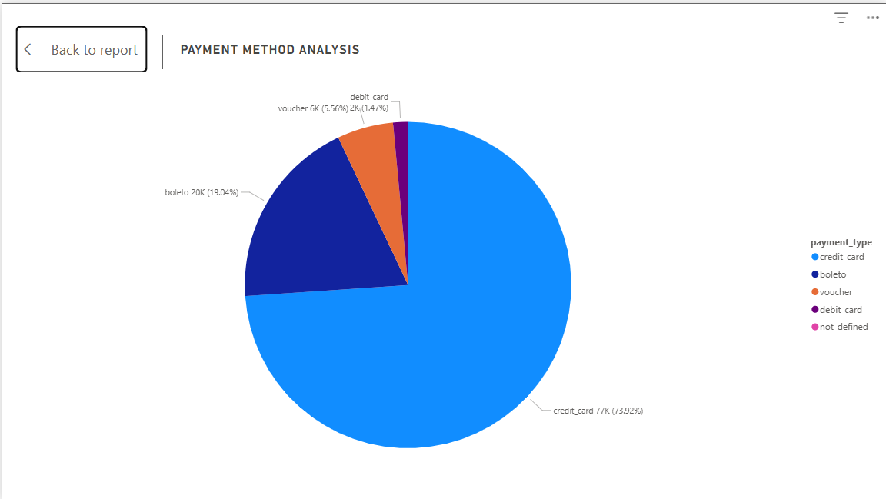

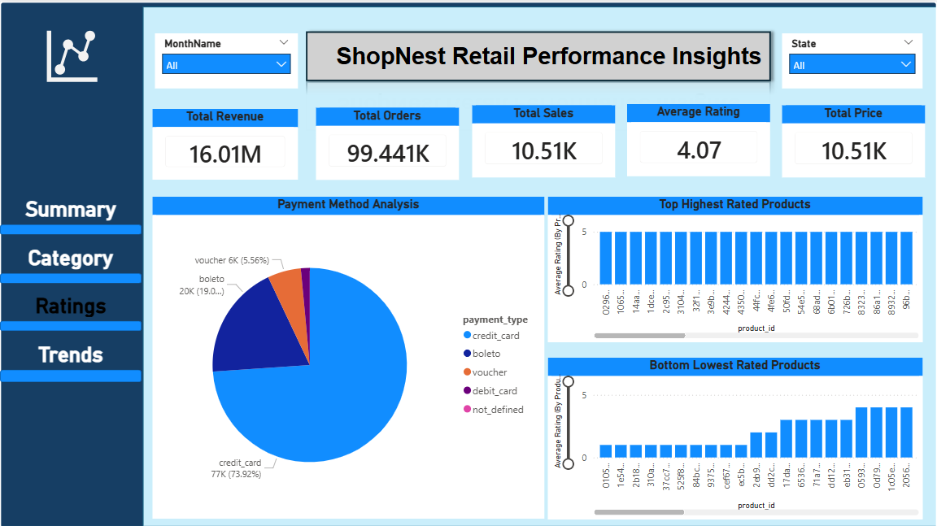

Payment Method Analysis

5) Product Rating Analysis — Top & Bottom 10
- Task 5:
  - Determine the top 10 highest-rated products and the bottom 10 lowest-rated products using a bar or column charts.
- Visuals: Two column charts for Top 10 highest-rated and Bottom 10 lowest-rated product IDs.
Explanation: For this task, I created two column charts in Power BI:
- One chart shows the Top 10 highest-rated products based on their average rating.
- The other chart displays the Bottom 10 lowest-rated products.
- From the visuals:
- The Top 10 products have ratings close to 5, indicating excellent customer satisfaction.
- The Bottom 10 products have ratings around 3 or lower, which suggests issues with product quality or customer experience.
- This analysis helps the business identify which products are performing well and which need improvement. High-rated products can be promoted, while low-rated products may require quality checks or better descriptions.
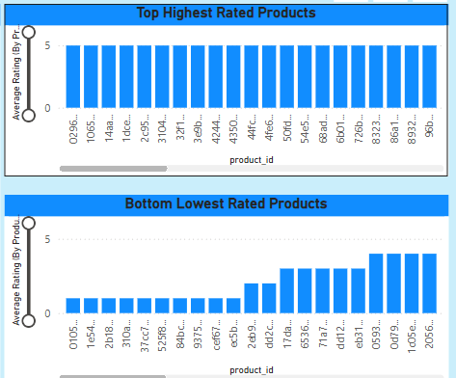
Top & Bottom rated products

6) State-wise Sales Analysis
- Task 6:
  - Identify and visually represent states with high and low sales, providing a clear understanding of regional sales performance.
- Visual: Filled map of Brazil states.
- Explanation: For this task, I created a Filled Map in Power BI to show sales performance across different states in Brazil.
- The map uses color intensity and markers to represent the total sales in each state.
- From the visual:
- States in the Southeast and South regions (such as São Paulo (SP), Rio de Janeiro (RJ), Minas Gerais (MG), Paraná (PR), and Rio Grande do Sul (RS)) have the highest sales.
- Northern states (like PA, RO, and others) show lower sales volumes.
- This analysis helps the business understand regional performance, so marketing and logistics strategies can be tailored to high-performing and low-performing areas.

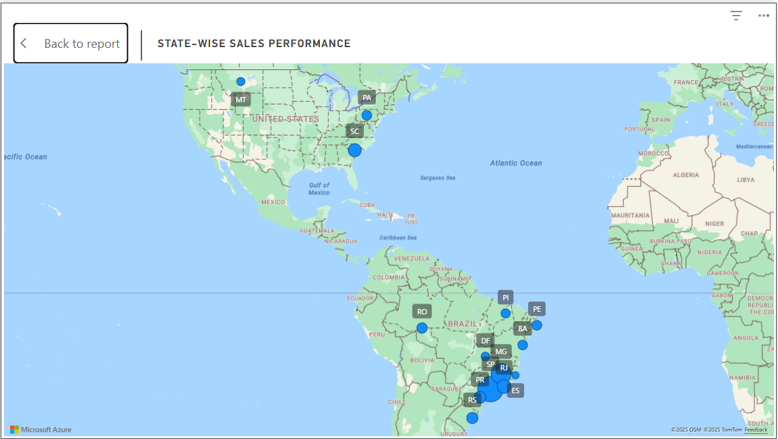
State-wise Sales Performance map

7) Seasonal Sales Patterns (Monthly/Quarterly)
- Task 7:
  - Investigate and visualize any seasonal patterns(Quarterly) or trends in sales data over the course of the year.

- Visual: Quarterly line chart
- Explanation: For this task, I created a Line Chart in Power BI to show seasonal sales patterns by quarter.
- The chart plots Total Sales against Quarter (Q1–Q4) to identify trends over the year.
- From the visual:
- Q2 has the highest sales with 4,047 units, indicating a strong seasonal peak.
- Q1 starts at 2,366 units, showing moderate performance.
- Q3 drops to 2,177 units, and Q4 is the lowest at 1,555 units.
- This analysis helps the business understand seasonal demand patterns, so inventory and marketing strategies can be aligned with peak periods (especially Q2).
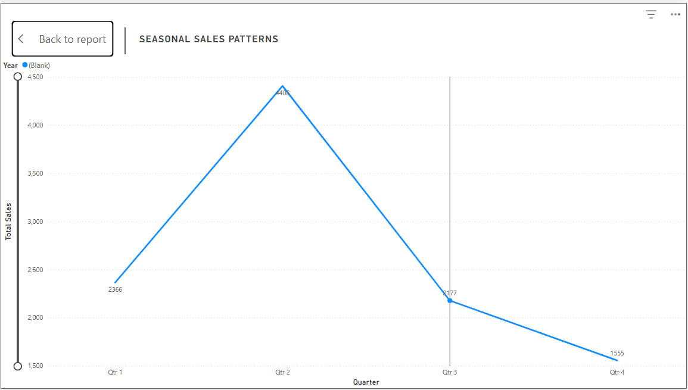
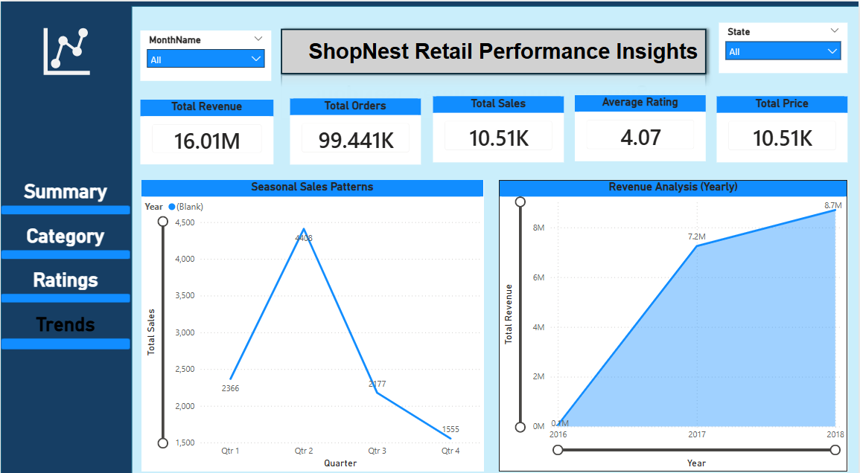
Seasonal Sales Patterns

8) Revenue Analysis (Yearly)
Task 8:
Determine the total revenue generated by ShopNest Store and analyze how it changes over time(Yearly). Represent this information through suitable visuals to highlight trends and patterns.
Visual: YoY revenue area/line chart. 2017 ≈ 7.2M; 2018 ≈ 8.7M → ~20.8% YoY growth.
Explanation: For this task, I created an Area/Line Chart in Power BI to show year-over-year revenue trends for ShopNest.
- The chart plots Total Revenue against Year to highlight growth patterns.
- From the visual:
  - Revenue in 2016 was near zero (start of operations).
  - In 2017, revenue increased significantly to ≈ 7.2M.
  - In 2018, revenue grew further to ≈ 8.7M, which is about 20.8% YoY growth compared to 2017.
- This analysis helps the business understand overall growth and plan strategies to maintain or accelerate revenue trends in future years.
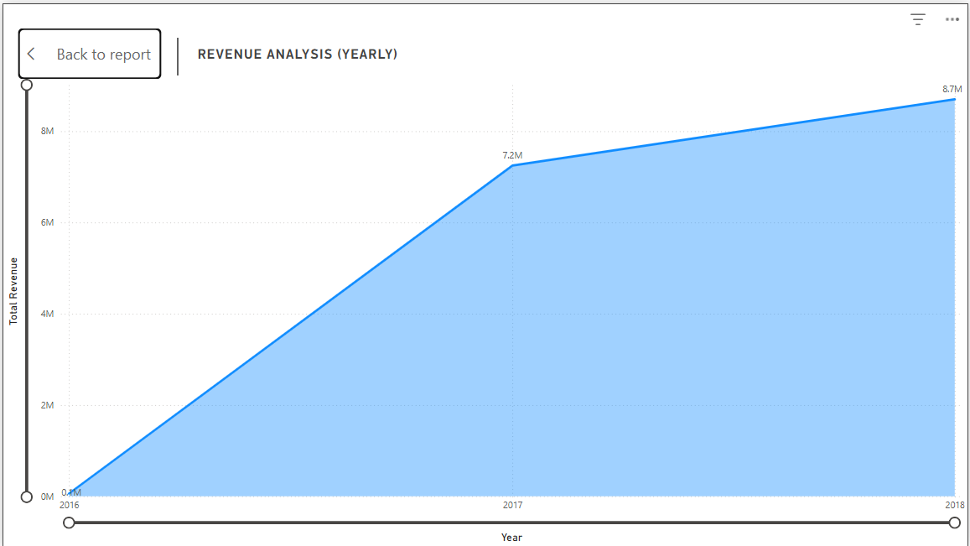

Revenue Analysis (Yearly)

Conclusion & Recommendations
Dashboard fulfills all eight tasks. Recommended next actions: focus top categories, fix computers delays, ramp capacity in peak months, optimize card processing, remediate low-rated SKUs, expand geographically, and plan campaigns around Q2 peaks.

